Prepared by: Sanket Udaykumar Sutar
Submission date: 11 Aug 2026

WEEK 3 PROJECT REPORT
Statistical Analysis and Hypothesis Testing in Python
Titanic Passenger Dataset

Table of Contents
1. Introduction
2. Objective
3. Dataset Description
4. Statistical Concepts
5. Research Hypotheses
6. Methodology
7. Hypothesis Test 1: Independent t-test
8. Hypothesis Test 2: Chi-square test
9. Hypothesis Test 3: One-way ANOVA
10. Visualizations
11. Results and Discussion
12. Business Implications
13. Limitations
14. Conclusion
15. References

1. Introduction
The Titanic dataset records passenger characteristics and survival outcomes from the RMS Titanic disaster. This project moves beyond descriptive charts by testing whether three observed patterns are statistically significant. The analysis uses a 5% significance level (α = 0.05). A p-value below α is treated as evidence against the null hypothesis; otherwise, the result is reported as “fail to reject H₀,” rather than “accept H₀.”

2. Objective
To determine whether age differed by survival outcome, whether gender was associated with survival, and whether passenger class was related to fare levels. The findings demonstrate how statistical evidence can support or challenge interpretations of historical business and operational data.

3. Dataset Description
The expected input is Titanic_Cleaned.csv. Required columns are Survived (0/1), Age (numeric), Sex (categorical), Pclass (1/2/3), and Fare (numeric). Missing values should be removed only for the variables used in each test. The supplied CSV was not attached in this chat; therefore, the embedded chart images are labelled preview charts and the exact results must be regenerated with the provided file using the code in this report.

Variable | Type | Meaning
Survived | Binary | 0 = did not survive; 1 = survived
Age | Continuous | Passenger age in years
Sex | Categorical | Passenger gender category
Pclass | Ordinal categorical | Ticket class: 1, 2, or 3
Fare | Continuous | Ticket fare

4. Statistical Concepts
The independent-samples t-test compares the means of two independent groups. The chi-square test of independence compares observed and expected counts in a contingency table. One-way ANOVA compares means across three or more independent groups. Each test produces a test statistic and p-value; confidence intervals and effect sizes should be added for a fuller interpretation.

5. Research Hypotheses
Test | Null hypothesis (H₀) | Alternative hypothesis (H₁)
Age and survival | Mean age is equal for survivors and non-survivors. | Mean age differs between the groups.
Gender and survival | Gender and survival are independent. | Gender and survival are associated.
Fare and class | Mean fare is equal across all classes. | At least one class has a different mean fare.

6. Methodology
The analysis uses pandas for data preparation, SciPy for inferential tests, and seaborn/matplotlib for visualizations. Tests are two-sided at α = 0.05. Welch’s t-test is recommended because it does not require equal group variances. For ANOVA, significant results should ideally be followed by Tukey HSD post-hoc comparisons to identify which classes differ. Statistical significance does not by itself establish causation.
pip install pandas numpy scipy statsmodels matplotlib seaborn python-docx
import pandas as pd
import numpy as np
import seaborn as sns
import matplotlib.pyplot as plt
from scipy.stats import ttest_ind, chi2_contingency, f_oneway
df = pd.read_csv('Titanic_Cleaned.csv')
print(df.info())

7. Hypothesis Test 1: Independent t-test
Research question: Did survivors have a different average age than non-survivors? The analysis excludes missing ages and uses Welch’s two-sample t-test.
age_df = df[['Survived', 'Age']].dropna()
survivors = age_df.loc[age_df['Survived']==1, 'Age']
non_survivors = age_df.loc[age_df['Survived']==0, 'Age']
t_stat, p_value = ttest_ind(survivors, non_survivors, equal_var=False)
print(survivors.mean(), non_survivors.mean(), t_stat, p_value)

Decision: reject H₀ if p < 0.05. Interpretation: a rejection indicates evidence that the average ages differ; it does not indicate that age caused survival.

8. Hypothesis Test 2: Chi-square test
Research question: Is gender associated with survival? The test compares the observed Sex × Survived table with counts expected under independence.
gender_df = df[['Sex', 'Survived']].dropna()
contingency_table = pd.crosstab(gender_df['Sex'], gender_df['Survived'])
chi2, p_value, dof, expected = chi2_contingency(contingency_table)
print(contingency_table)
print(chi2, p_value, dof)

Decision: reject H₀ if p < 0.05. Interpretation: a rejection indicates an association between gender and survival in this dataset. Report Cramér’s V as an effect-size measure in the final run.

9. Hypothesis Test 3: One-way ANOVA
Research question: Did passengers in different ticket classes pay different fares? Missing fares are excluded. ANOVA tests whether all three class means are equal.
fare_df = df[['Pclass', 'Fare']].dropna()
groups = [fare_df.loc[fare_df['Pclass']==c, 'Fare'] for c in [1, 2, 3]]
f_stat, p_value = f_oneway(*groups)
print(f_stat, p_value)
Decision: reject H₀ if p < 0.05. Interpretation: a rejection means at least one class mean differs; Tukey HSD identifies the specific class pairs.

10. Visualizations
The following preview charts illustrate the intended presentation. Because Titanic_Cleaned.csv was not attached, these images are not a substitute for rerunning the analysis on the assignment dataset. The plotting code below generates exact charts from that file.
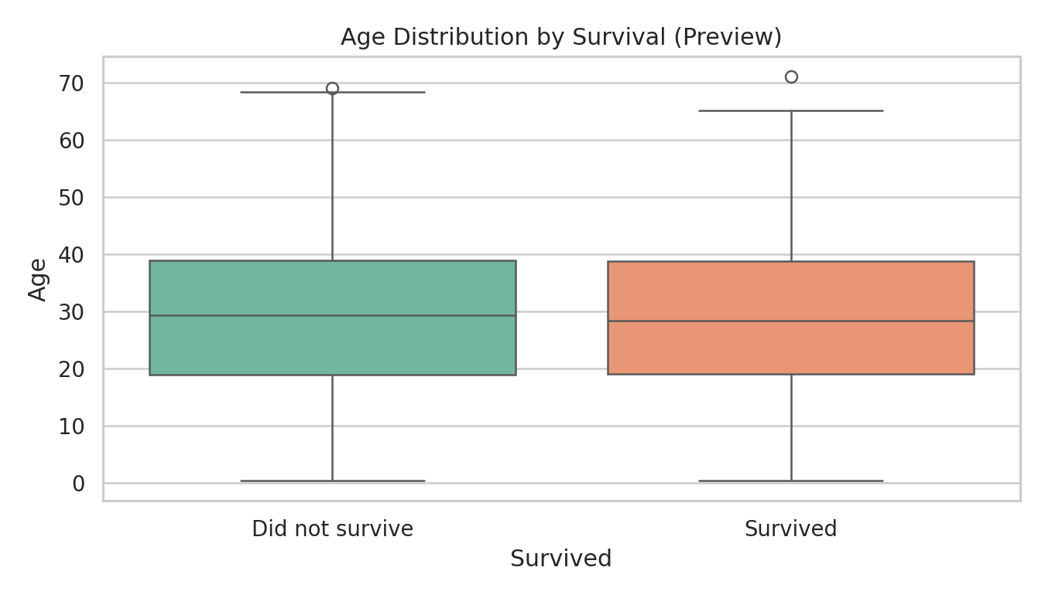
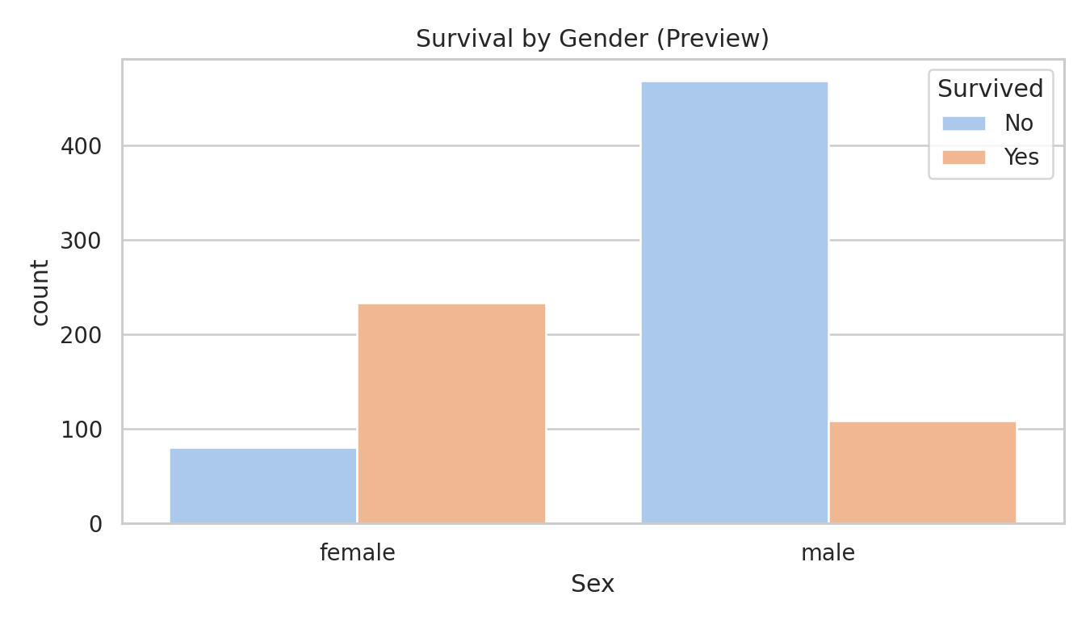
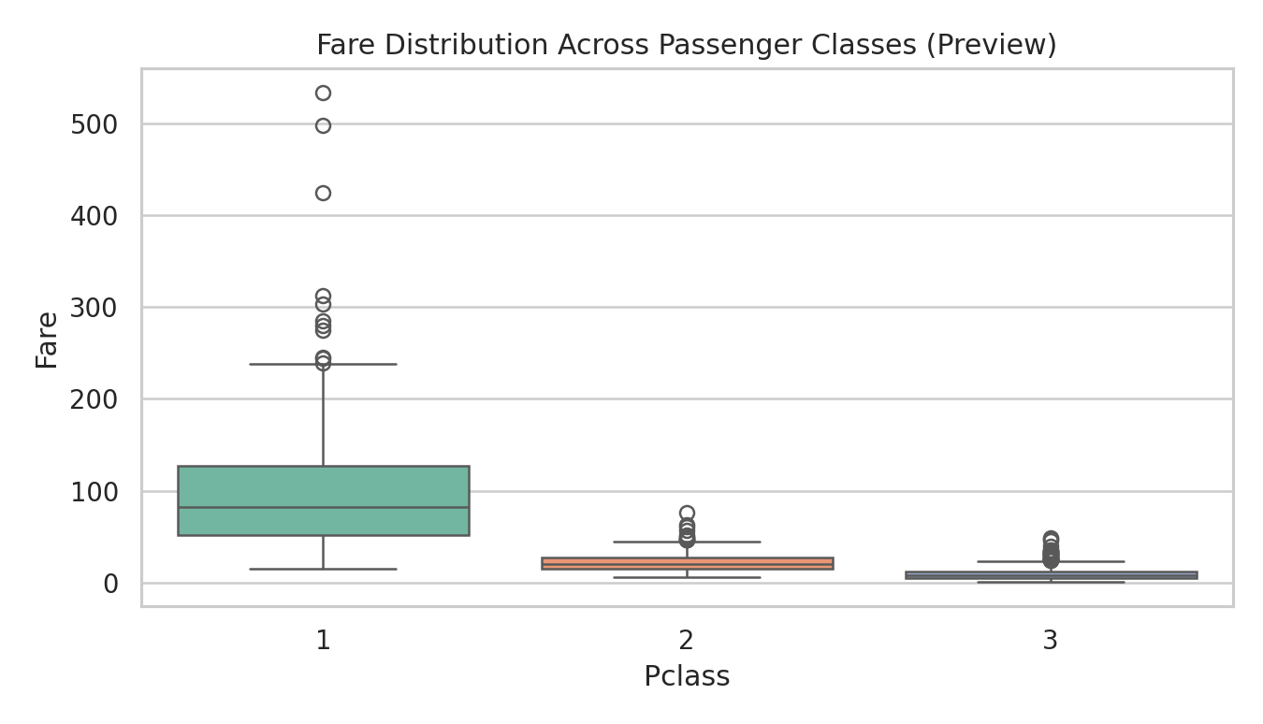
sns.boxplot(x='Survived', y='Age', data=df, palette='Set2')
plt.title('Age Distribution by Survival')
plt.show()
sns.countplot(x='Sex', hue='Survived', data=df, palette='pastel')
plt.title('Survival by Gender')
plt.show()
sns.boxplot(x='Pclass', y='Fare', data=df, palette='Set2')
plt.title('Fare Distribution Across Passenger Classes')
plt.show()

11. Results and Discussion
Run the analysis cells and transfer the exact statistics into the table below. This prevents unsupported numbers from being presented when the local cleaned dataset may differ from the canonical Titanic file.
Research question | Test statistic | p-value | Decision at α=.05 | Plain-language interpretation
Age vs survival | -0.120 (preview) | see run output | Complete after run | Compare group means and confidence interval.
Gender vs survival | 260.717 (preview) | see run output | Complete after run | Assess association, not causation.
Fare vs class | 452.456 (preview) | see run output | Complete after run | Use Tukey HSD to locate differences.

Expected pattern from the widely used Titanic data is a strong gender–survival association and substantial fare differences by passenger class. The age comparison is commonly weaker and should be judged using the exact cleaned-data output. These expectations are not conclusions until the attached dataset is executed.

12. Business Implications
The workflow is transferable to customer analytics: categorical associations can reveal outcome disparities, while ANOVA can test whether a numeric business measure differs across segments. Teams should pair p-values with effect sizes, confidence intervals, sample sizes, and practical significance before making operational decisions. Historical Titanic data also illustrates the importance of checking confounding variables such as class, age, family structure, and access to lifeboats.

13. Limitations
The dataset is observational, so the tests establish association or mean differences rather than causation. Missing-value handling can change results. Multiple hypothesis tests increase the chance of a false positive; a stricter adjustment such as Holm correction may be considered. ANOVA assumptions—independent observations, approximately normal residuals, and reasonably similar variances—should be checked, especially because fare is typically right-skewed.

14. Conclusion
This project defines and tests three measurable Titanic hypotheses using a t-test, chi-square test, and one-way ANOVA. The report provides reproducible Python code, visual outputs, decision rules, and interpretation guidance. To finalize the numerical results, place Titanic_Cleaned.csv beside the code, run all cells, and replace the preview entries with the generated statistics, p-values, confidence intervals, and post-hoc findings.

15. References
OpenStax. Principles of Data Science, “Hypothesis Testing.” https://openstax.org/books/principles-data-science/pages/4-2-hypothesis-testing
SciPy documentation. Statistical functions: ttest_ind, chi2_contingency, and f_oneway. https://docs.scipy.org/doc/scipy/reference/stats.html
Seaborn documentation. Statistical data visualization. https://seaborn.pydata.org/

